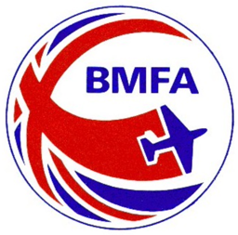

Notes of meeting held on Monday 15 July to plan 2025 Board and Executive meeting dates.

Present: Ian Pallister, Dave Phipps, Linda Harding, Simon Vaitkevicius and Paul Hoey

Apologies: Duncan McClure

Planning assumptions
- The January Board meeting to be later in the month (25th) to allow Technical and Areas Council to meet in the new year.
- Simon to propose Technical meeting dates in due course.
- The January Board meeting to continue to be on a Saturday whereas the May and September Board meetings to be on a Thursday evening.
- The Executive to meet on the 2nd Thursday of non-Board meeting months.

Thursday 23rd January | Areas Council
Wednesday 22rd January | Technical Council
Saturday 25 January | Board meeting (papers out no later than Friday 3 Jan)
Thursday 13 February | Executive
Thursday 13 March | Executive
Thursday 10 April | Executive
Tuesday 6th May | Areas Council
Wednesday 7th May | Technical Council
Thursday 8 May | Board meeting (papers out no later than Thursday 17 April)
Thursday 12 June | Executive
Thursday 10 July | Executive
Thursday 14 August | Executive
Wednesday 3rd Sept | Technical Council
Thursday 4th September | Areas Council
Tuesday 9 September | Board Budget meeting (papers out no later than Tuesday 19 August for both meetings)
Thursday 11 September | Board Business meeting
Saturday 1 November | AGM
Thursday 11 December | Executive

Paul Hoey
Version 3
1.9.24

