BMFA Strategic Risk Assessment

Purpose: This paper is for the attention of the BMFA Board. It sets out a model for strategic management at Board level to ensure the sustainability and growth of the BMFA.

Action: The Board is asked to review the paper and decide how it wishes to respond to the issues raised and the suggested actions.

Introduction.

A strategic risk assessment (SRA) is a systematic, continuous process for the BMFA Board to identify its strategic risks and understand how those risks are being managed across the business. “Strategic risks” are the risks that are most consequential to the BMFA’s ability to execute its strategy and achieve its objectives. They entail the risk exposures that can ultimately impact performance or even threaten the BMFA’s survival in its current form.

At Board level, strategic risks may be categorised into 9 headings as in Diagram 1 below. Those in green are external risks and those in blue are internal risks.

Diagram 1: The 9 Areas of Strategic Risk as identified by Cascade Strategy

Regulatory Risk  Compliance and legal rule changes | Competitor Risk  Threat from rival organisations | Economic risk  Vulnerability to economic fluctuations
Political risk  Impact of political factors | Change risk  Disruption due to change | Reputational risk  Damage to brand image
Governance risk  Issues in organisational governance | Financial risk  Exposure to financial uncertainties | Operational risk  Hazards in day to day operations

The BMFA Strategic Risk Assessment

Board Action: Individual Directors to take responsibility for an area of risk, and reporting to the Board in their Directors report.

The Board has identified the following risks as having the potential to have serious impact on the BMFA. These are listed in columns A and B below. Column A references back to Diagram 1. Columns D, E, F and I are the RAG ratings where Green is the risk is managed and acceptable, Amber means the there is some risk and attention is required and red means the risk is significant and not sufficiently mitigated. Regular review would identify if the RAG rating is moving, for example, from green to amber or from red to amber. It is the direction of travel that matters, thereby highlighting effectiveness of action taken.

Diagram 2:

 | A | B | C | D | E | F | G | H | I
 | External/Internal | Description | Consequence | Probability | Impact | Risk level | Risk mitigation plan | Risk owner | Residual risk level
1 | Regulatory | 1.Adverse legislation restricting model flying | Restrictions on model flying and unwillingness of members to engage and maintain membership |  |  |  | Maintaining the strong relationship with the CAA and other aviation regulatory bodies  Positive messaging | 1.CEO
2 | Financial and Competitor | 1.Declining membership due to age profile and potential legislative impact  2. Members opt for FPV UK  3. Buckminster incurring significant financial loss | Loss of income leading to downsizing of the organisation.  Loss of local flying facilities leading to loss of members and clubs. |  |  |  | 1.Quarterly management accounts to the Board  2. Reserves Policy | 1.Finance Director  2.&3. CEO
3 | Operational | 1. A serious model flying accident.  2.Loss of flying sites | Potential for greater scrutiny by AAIB & CAA |  |  |  | 1.Members handbook  2.Achievement Scheme  3. Advice to clubs | 1.CEO & ASRC  2.Development Officer
4 | Reputational and Political | 1.A serious safeguarding incident  2.A serious model flying accident. | Potential for regulatory and media scrutiny |  |  |  | 1.Revised guidance to clubs.  2.Staff training  3.Advice and support to clubs | 1. CEO, Club Support Officer & Outreach Director
5 | Change and Operational | 1.Loss of key staff and lack of Volunteers | Failure to fill vacant posts and loss of capacity to deliver governance, services and events |  |  |  | Continuity planning, talent spotting and nurturing | 1. Chairperson, Outreach and Members Directors.  Honorary Secretary
6 | Regulatory and Operational | 1.IT Failure causing loss of data including Azolve membership system | Data Commissioner scrutiny |  |  |  | Contracts with specialist IT providers  Cloud storage | 1. CEO  Club Support Officer

Addressing the Challenges of the Strategic Risk Assessment

A strategic risk assessment by its very nature requires action at Board level. The following sections summarise a number of practical measures that the Board may implement to address the challenges of the SRA.

Performance data and base lining

This involves systematically collecting and reporting statistical data which informs the status of the BMFA and the direction of travel. We currently collect membership and club data but without any systematic interrogation to draw out trends and advise targeted planning. Other data available to the Board which could be extracted is:

- Membership age and numbers and trends
- % of members holding the RCC
- % of members holding Achievement Scheme awards by type
- No of Achievement Scheme Awards per annum (maybe by age)
- Reportable accidents by type
- Buckminster user groups and per head numbers
- Output figures relating to specific projects against targets
- Media and digital contacts by type
- Other media exposure

The above data would be presented as headline figures in tables or graphs as most appropriate to evidence trends ideally through a summary Data Dashboard as shown overleaf for illustrative purposes.

Diagram 3: Data Dashboard
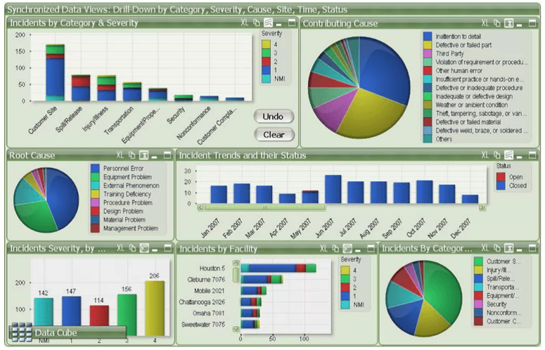

Finance and Budgeting

Inevitably financial management and reporting is integral to the above approach. Plans should be costed and monitored with Management Accounts routinely presented to the Board.

The Finance Director is working to restructure the accounting system which, in turn, will enable the Board to have a better understanding of the Association’s financial position

Planning and reporting

Planning in the context of this document relates solely to strategic rather than operational planning and is advised by the priorities exposed by the SRA and set by the Board. Essentially, strategic planning is to mitigate risk and turn the curve where data shows a need.

Once the Board has agreed its strategic priorities and the SMART targets each Director identifies how their area of responsibility contributes through an annual plan agreed by the Board co-operatively at the January meeting. The collective plans form the Boards strategic plan.

This will require a different approach to Director reporting. Reports will need to be split into at least 2 sections, firstly reporting against the priorities of their annual plan and secondly, reporting on other matters. The former involves Board discussion and co-ordination the latter information sharing and little discussion.

Agenda formation will need to be changed to focus on performance and clarity of purpose for any agenda item. Consequently, Director reports will need to flag the important matters for discussion and propose future action.

The Annual Plan should be a short document, ideally;
- be costed;
- be no more than 2 sides of A4;
- closely relate to the data dashboard; and
- advise planning in years 2 and 3.

Governance meeting schedule:

Board members have briefly discussed the need to meet more frequently. A schedule of meeting dates for 2025 is appended at the end of this document.

Planning assumptions

- The January Board meeting to be later in the month (25th) to allow Technical and Areas Council to meet in the new year.
- The January Board meeting to continue to be on a Saturday whereas the May and September Board meetings to be on a Thursday evening.
- The Executive to meet on the 2nd Thursday of non-Board meeting months.

Thursday 23rd January | Areas Council
Wednesday 22nd January | Technical Council
Saturday 25 January | Board meeting (papers out no later than Friday 3 Jan)
Thursday 13 February | Executive
Thursday 13 March | Executive
Thursday 10 April | Executive
Tuesday 6th May | Areas Council
Wednesday 7th May | Technical Council
Thursday 8 May | Board meeting (papers out no later than Thursday 17 April)
Thursday 12 June | Executive
Thursday 10 July | Executive
Thursday 14 August | Executive
Wednesday 3rd Sept | Technical Council
Thursday 4th September | Areas Council
Tuesday 9 September | Board Budget meeting (papers out no later than Tuesday 19 August for both meetings)
Thursday 11 September | Board Business meeting
Saturday 1 November | AGM
Thursday 11 December | Executive

Specific, Measurable, Achievable, Realistic, Timed

